Bahria University,

Karachi Campus



COURSE: CSL-320 OPERATING SYSYTEM

TERM: SPRING 2022, CLASS: BSE- 4(B)

Submitted By:

**M Muaz Shahzad 02-131202-081**

(Name) (Reg. No.)

Submitted To:

Engr. Rizwan Fazal/ Engr. Rahemeen

Signed Remarks: Score:

INDEX

|  |  |  |  |  |
| --- | --- | --- | --- | --- |
| SNO | DATE | LAB NO | LAB OBJECTIVE | SIGN |
| 01 | 7-Mar-22 | 01 | Intro to Linux |  |
| 01 | 14-Mar-22 | 02 |  |  |
|  |  |  |  |  |
|  |  |  |  |  |
|  |  |  |  |  |
|  |  |  |  |  |
|  |  |  |  |  |
|  |  |  |  |  |
|  |  |  |  |  |
|  |  |  |  |  |
|  |  |  |  |  |
|  |  |  |  |  |

Bahria University,

Karachi Campus



LAB EXPERIMENT NO.

**01**

LIST OF TASKS

|  |  |
| --- | --- |
| TASK NO | OBJECTIVE |
| **01** | By using the command line shell interface, practice the commands given in this lab. Write  briefly about the usage of each command. |
| **02** | By using gedit, open a text editor and write the C program That print your name. Save the  written file as “name.c”. In order to compile and execute the output file, do the following:   * $ gcc - o name name.c * $ ./name |
| 03 | Make changes within the above program to display a new output text as given below. Write down the developed program.   * Hello World! I am studying Operating Systems. * My name is “Enter your name”. * My registration number is “Enter your registration number”. * I belong to Bahria University Karachi Campus. |

Submitted On:

21-march-2022

**Task No. 1: By using the command line shell interface, practice the commands given in this lab. Write**

**briefly about the usage of each command.**

**Solution:**

1. **date Command:**

Use to display date and time.

**Output:**

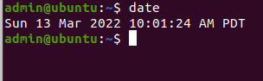

1. **pwd Command:**

The pwd command prints the current working directory path, starting from the root

**Output:**

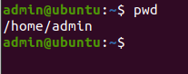

1. **mkdir –p:**

**Output:**

With the help of mkdir -p command you can create sub-directories of a directory.

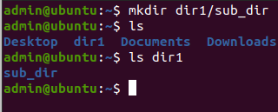

1. **mkdir –v:**

'mkdir -v' command will print a message that tell info about creation of directory

Output:

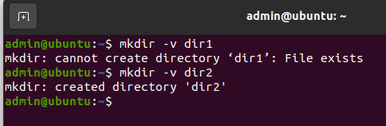

1. **ls –l:**

It is used to list information about files and directories within the file system.

**Output:**

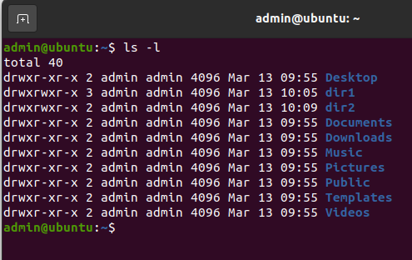

1. ls –a:

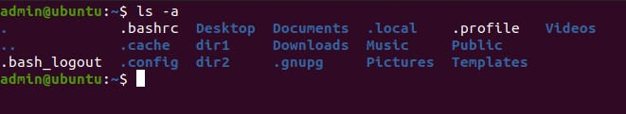 **Output:**

1. ls –h:

**Output:**

ls -a will list all files including hidden files.

The ls -h command is used for display content in human readable form

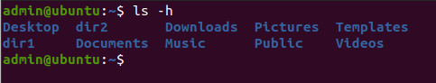

**Task No. 2: By using gedit, open a text editor and write the C program That print your name. Save the**

**written file as “name.c”. In order to compile and execute the output file, do the following:**

* **$ gcc - o name name.c**
* **$./name**

**Solution:**

#include <stdio.h>

void main()

{

printf("My Name is Muaz Shahzad");}

**Output:  
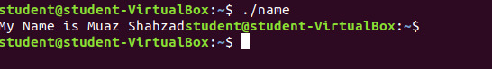**

**Task No. 3: Make changes within the above program to display a new output text as given below. Write down the developed program.**

* **Hello World! I am studying Operating Systems.**
* **My name is “Enter your name”.**
* **My registration number is “Enter your registration number”.**
* **I belong to Bahria University Karachi Campus.**

**Solution**

#include<stdio.h>

void main(){

char n[100];

int reg;

printf("Enter your name: ");

scanf("%s",n);

printf("Enter your Registration number: ");

scanf("%d",&reg);

printf("Hello! I am studing Operating system \n My name is %s \n My registration num is %d \n I belong to Bahria University \n",n,reg);

}

**Output:**

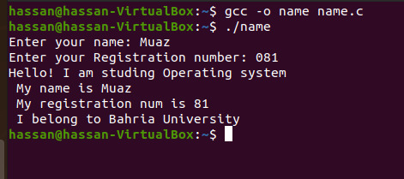

Bahria University,

Karachi Campus



LAB EXPERIMENT NO.

**02**

LIST OF TASKS

|  |  |
| --- | --- |
| TASK NO | OBJECTIVE |
| 01 | Practice all the Linux commands discussed in this lab while taking assistance using the man command. Write the complete syntax used for utilizing the cp, mv and rm commands in Linux shell. |
| 02 | Write the C programs provided in this lab and generate their outputs over Linux environment (provide snapshot). |
| 03 | Write a C program on the Linux environment that takes your marks as an input and display your grades accordingly to that followed at Bahria University. Limit your program to a maximum of five subjects. Use the suitable logical operator(s), i.e. and (&&), or (||), not (!), if required |
| 04 | Write a shell script to display your address over multiple lines. |
| 05 | Write a shell script that would traverse among any three directories that are placed under the /home directory. While moving from one directory to another, the script should display the name of the current working directory and list the content within that directory, including the hidden files. |

Submitted On:

21-march-2022

**Task No. 1: Practice all the Linux commands discussed in this lab while taking assistance using the man command. Write the complete syntax used for utilizing the cp, mv and rm commands in Linux shell.**

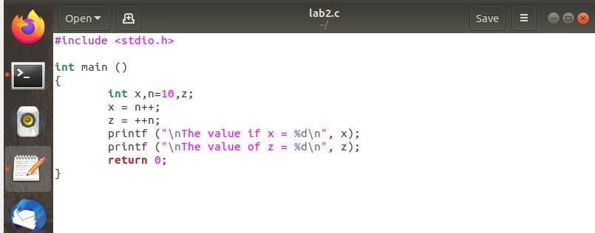**Solution:**

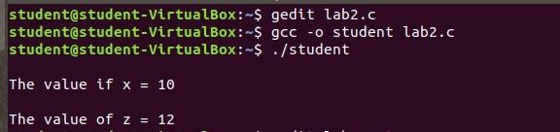**Output:**

**Task No. 2: Write the C programs provided in this lab and generate their outputs over Linux environment (provide snapshot).**

**Solution:**

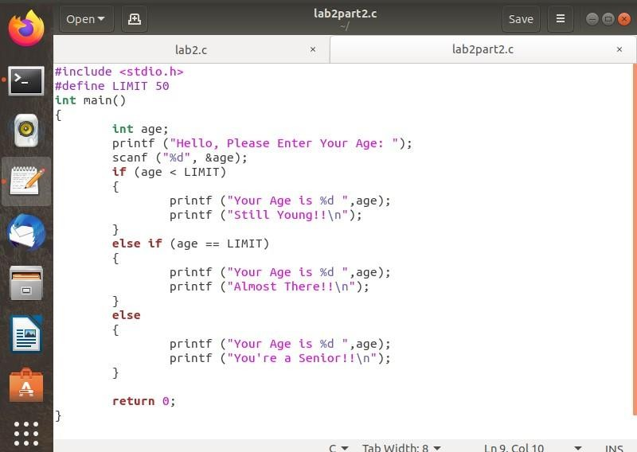

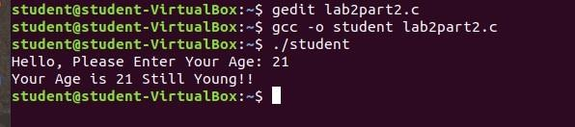**Output:**

**Task No. 3: Write a C program on the Linux environment that takes your marks as an input and display your grades accordingly to that followed at Bahria University. Limit your program to a maximum of five subjects. Use the suitable logical operator(s), i.e. and (&&), or (||), not (!), if required**

**Solution:**

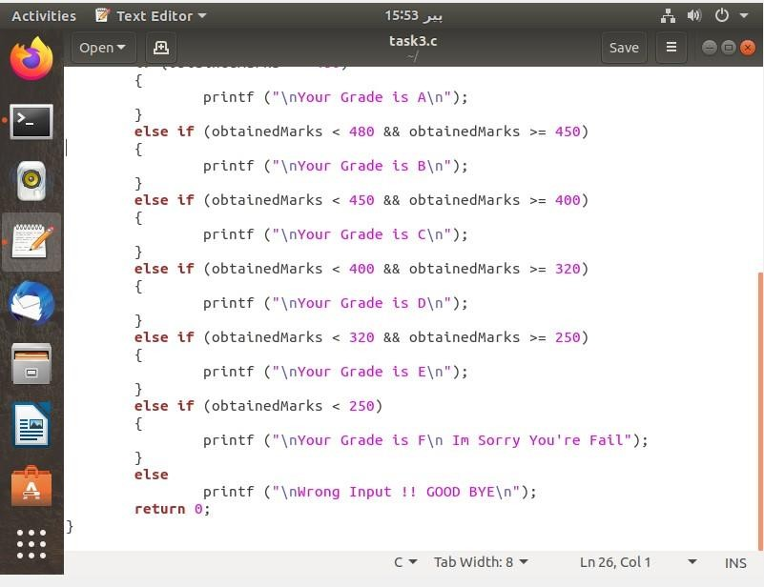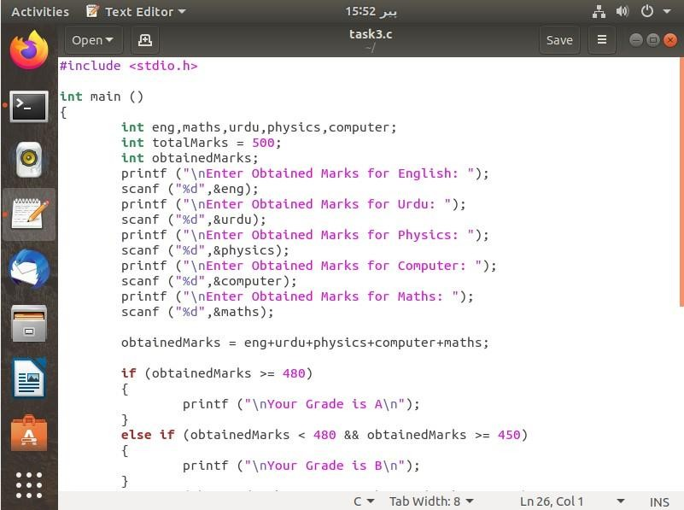

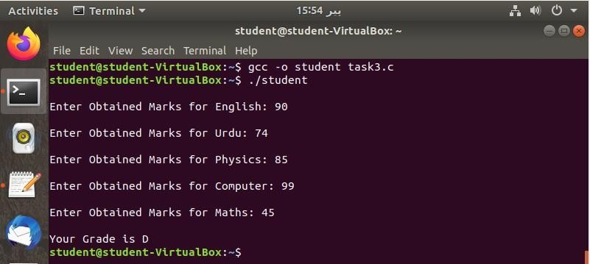**Output:**

**Task No. 4: Write a shell script to display your address over multiple lines.**

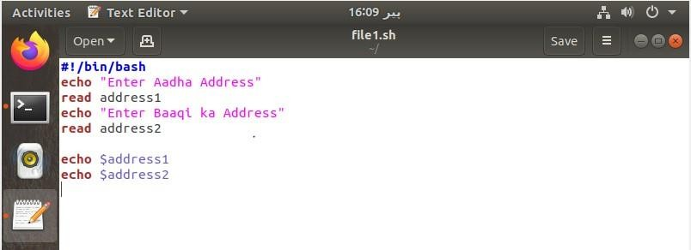**Solution:**

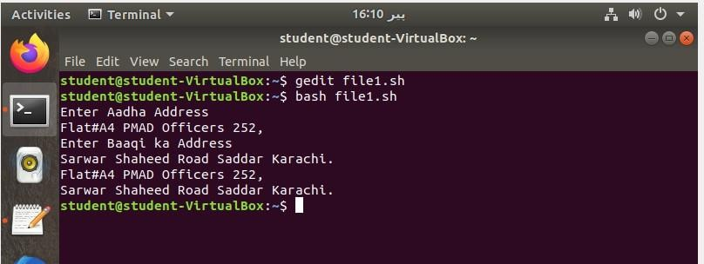**Output:**

**Task No. 5: Write a shell script that would traverse among any three directories that are placed under the /home directory. While moving from one directory to another, the script should display the name of the current working directory and list the content within that directory, including the hidden files.**

**Solution:**

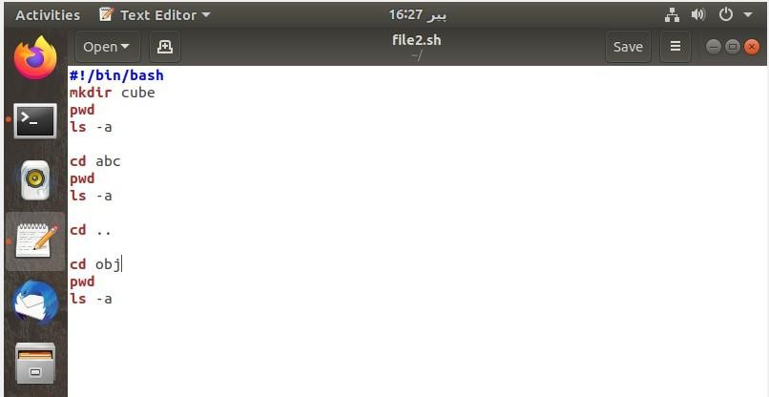

**Output:**

